**Related Work**

(Write about apps on the market that are alike to ours)

Since the serious game is going to be an Android app, the obvious first step was to explore the Google Play, in order to create an idea, what is the actual supply of apps similar to the one intended to create, and also their current stage of the development.

After inputting “Project Management Apps” on the search field, a very rich array of results came up. The top 100 apps were reviewed and were partitioned into lists according to their features. The majority of the suggestions were apps designed with the main purpose to track progress of projects, i.e. tools that the management can use to monitor task assignment and completion of the employees, the to-do lists of the project, a platform to arrange meetings etc. These particular apps are not related to this project, so they were discarded.

(Here write the Top 10. For the first 7 give a brief description. For the top 3 go into details)

The family of apps that are of interest to our serious game, are the one that introduce and elucidate concepts of (IT) projects and their management, provide questions to the previous explained theory, and one of the most important characteristics searched for was the injection of gamification elements into it. Here is a list of the top results, that checked all/the majority of the marks:

1. Learn Project Management ([Link](https://play.google.com/store/apps/details?id=com.quizmine.projectref_01))
   * The user has a rich offering of chapters like “Introduction to project management”, “Role of a project manager”, “Project basics” etc. When the user clicks on one of these subjects, a new window (find the app equivalent) opens where the user can choose between a tutorial about the field or opening the quiz about it.
     1. If the user opens up the tutorial, a list is presented, where all the topics that will be explained are displayed. Below this listing the user sees the above topics explained in more detail in bullet points listing
     2. If the user opens up the quiz, all the material explained on the tutorial section, is asked through a multiple choice questionnaire. A timer is also started with each question. When the time is up, the user is redirected to the next question, thus losing the ability to collect (more) points.
2. Software Project Management: [Link](https://play.google.com/store/apps/details?id=com.faadooengineers.free_softwareprojectmanagement)
   * The user can choose between an abundant array of options on the main screen. They enhance the study experience and can go together with a good deal of moods. This allows him to interact with the app more frequently, increasing the learning curve and augmenting the information acquisition. The options and a short description of them is listed below:
     1. Study Materials:
        + It is separated in three units, namely “Conventional Software Management”, “Software Management Process”, “Software Management Disciplines”. Each unit has a different amount of topics. When a topic is clicked, a window is opened with an explanation of it. Furthermore each topic can be seen offline, shared or inserted to favorites.
     2. Most Searched Topics:
        + A very rich and long scrollable list of topics is presented to the user. An interesting feature is that for each clicked topic, a window opens itself where the search result of it on “Faadoo”, “YouTube” and “Wikipedia” are revealed.
     3. Test
        + Here the user is provided a questionnaire of 10 questions. It has four alternatives and only one of them is right. When a choice is clicked and submitted an instant evaluation is displayed that says either “Wrong Answer, the correct one is: *Here comes the correct choice*” or “Right answer”.
     4. Videos
        + An amount of topics that are part of management of software projects are taught through video tutorials. It allows the user to get the information in an animated way.
     5. Study Abroad
        + Another interesting feature is the “Study abroad” option. It shows the top 5 countries with international students and for each it lists some reasons why to choose that particular destination, its popular courses and universities, application procedures on how to get a visa but also how to enroll in an university.
     6. Study Reminder
        + Thanks to this option a reminder can be set, and so the user will receive a notification when it is time to study.
     7. My Progress
        + It shows the reading progress of the user, i.e. the all of the topics that he as read.
     8. My Favorite
        + It lists all the topics marked as favorite by the user.
     9. More Books
        + It shows a list of related engineering and science learning games, like for example “Computer Science Apps”, “Electrical Engineering Apps”, which when clicked present a formation of that topic’s associated apps on Google Play.
3. Project Management: [Link](https://play.google.com/store/apps/details?id=app_projectmanagement.EN)
   * A very well done educational game from the “FernUniversität in Hagen”. Here is the structure of the app:
     1. It is divided in chapters like “Introduction: Basics of Project Management”, “Planning and Organizing Projects in the Planning Phase” or “Practical Aids”.
     2. For each chapter there are subchapters which divide it into smaller pieces for better information acquisition.
     3. To further enhance it, each subchapter is divided into (on average 4) pages. As we can see the goal is to have snack sized pieces of information taught to the user.
     4. To provide another alternative to teaching, not just the plain old reading of a text, the app has introduced case studies, so that the user can absorb the context differently.
     5. An interesting feature is the “Practical Task”: The user is presented a question for which he can write an answer inside a Text Editor. With it the user sees where does his actual knowledge about the topic stand. Below the editor a “Sample Solution” is provided.
     6. The subchapter before the last is “Summary” which recapitulates the whole chapter briefly.
     7. The last subchapter is “Exercises”. On it a few multiple choice questions about the subjects explained in the previous subchapters are given to the user. After submitting, the user sees what were the correct ones. Also a link to the subchapter where the concept was explained is provided below the respective questionnaire.

Other Serious Games not found on Google Playstore

* A company that provides a good deal of serious games tailored to costumer requirements is “Designing Digitally”(Insert link as reference).
  + “AUGMENTED REALITY RESOURCE MANAGEMENT” is the name of a game they created for a large construction enterprise, that wanted to address an ever occurring phenomenon inside their walls, where the managers were struggling with resource allocation in the majority of the from their undertaken projects.
    - Because the managers did not have access to computers during their quarterly training seminar, it was decided to create a mobile app, whose experience would be (syn: augmented) by introducing augmented reality elements.
    - On this serious game implementation the managers would virtually practice their on-field doings, i.e. task distribution to the (syn virtual) employees, material and equipment divided amongst all the actors participating in all parallel ongoing projects, all under time restriction and hence pressure.
    - All that was needed to participate in the game was a smartphone and some printed playing cards. When the phone camera was directed to a card, it was transformed into a movable 3D object, and by moving it with a finger, this card/resource was moved to another position and simultaneously allocated. The better the allocation, the more points did the user get.
    - The feedback for this game-based learning experience was very positive and the implementation praised by the costumer. The users/managers reported an increase in competence and recalling the information learned. The construction company intends to continue with the app during the next quarter seminar and hopes the experience would map itself in the real world projects undertaken by the managers.
  + “SIMULATED ETHICS” is another app created by Designing Digitally Inc to address a delicate issue that the HR department in every company faces: Workplace ethics.
    - Due to budget constraints, it was not possible to organize seminars where subjects like harassment, misconduct etc. and the respective reaction paradigms would be discussed. That’s where an serious game comes to play
    - The issue would be attacked by creating a web-based App, so that it could be accessible to each company member. In it two reoccurring roles, namely “attacker” and “victim”, are presented in different scenarios of everyday work. For each (syn scenario) a few alternatives are presented, how an actor should react to the situation, and based on the answer provided by the user, the (syn outcome) changes.
    - The product was implemented into the company and used to school more than 20.000 employees about those delicate matters and how they should conduct themselves in their workplace.
* Another software company which engages in creation of serious games is “Serious Games Store”(Link as reference). The offer a plethora of subject based trainings programs like: Conflict Management, Time Management, Remote Management, Entrepreneurship, Communication, Delegation etc. The paradigm is to divide the teachings on each subject in three short and thus digestible 3D animated motion pictures so that the learning is not boring at all. Some of these programs are:
  + Conflict Management: WRITE ABOUT CONFLICT MANAGEMENT(SCREENSHOT/PDF)
  + Time Management:
    - This training program is divided in three sections/situations: Organizing time, manage time and delegate a task. For each one of this situations an animated moving picture shows how a manager should behave when presented with a situation.
* CIO Planspiel is a software implementation from the Chair for Information Business Systems at the Technical University of Munich. It is intended as a learning platform for a practical course offered to enrolled informatics Master of Science students.
  + In it the user/student takes the roles of: Chief Information Officer (CIO), Chief Financial Officer (CFO), Chief Marketing Officer (CMO) or Chief Operations Officer (COO) in a fictional company called “TechniCar Autobank”. The company is specialized in car financing and saving account. Like accustomed in manager training games the user is provided with diverse company resources and faces diverse situations, where he/she has to allocate the resources through his best judgement. The situations are interconnected so each decision taken should be calculated correctly as it will ignite a chain reaction. The implementation is web based but with no animation features or any other property seen on the previous two examples. The user is presented with a table, where he/she has to insert a value on an input field and in that way the resource allocation for that particular case is (synonym for done).
  + 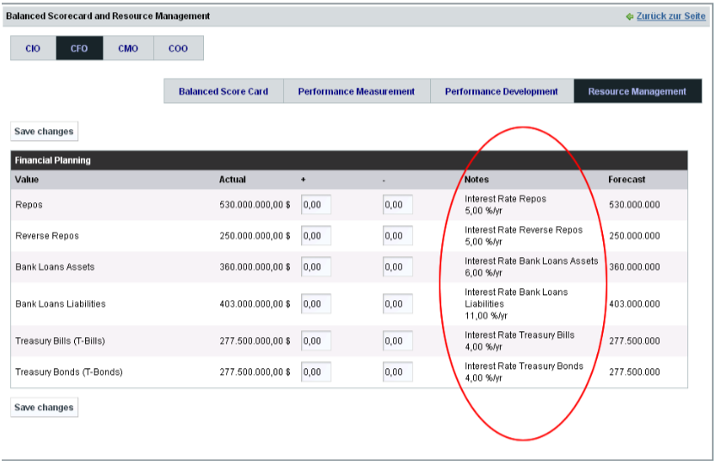

In the picture above…

CIO PLANSPIEL

Screenshots for every game/subject.

(Write about your game design )